**Write an application in C++ using appropriate exceptions. Perform the given operations.**

* Read and fill a string array with atleast 2 inputs from command line.   
  Incase of incorrect number of arguments(less), throw an exception with error message as "Insufficient arguments. Enter atleast 2 or more strings", catch and handle this exception.
* Prompt, read an index, fetch the string at given index from string array. If index is invalid raise

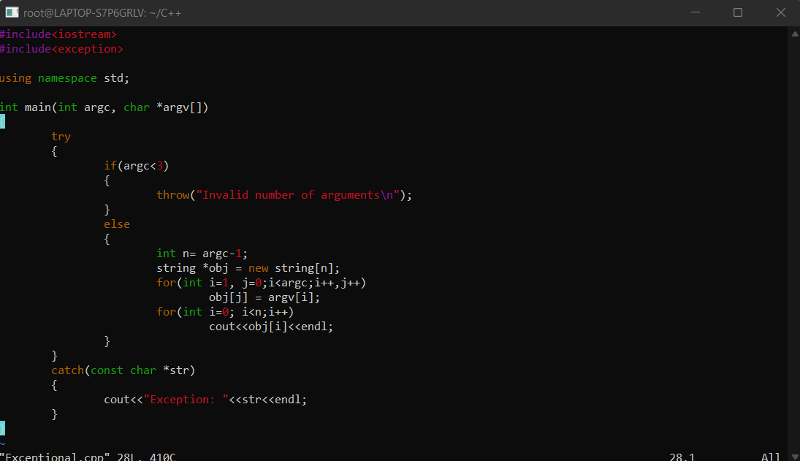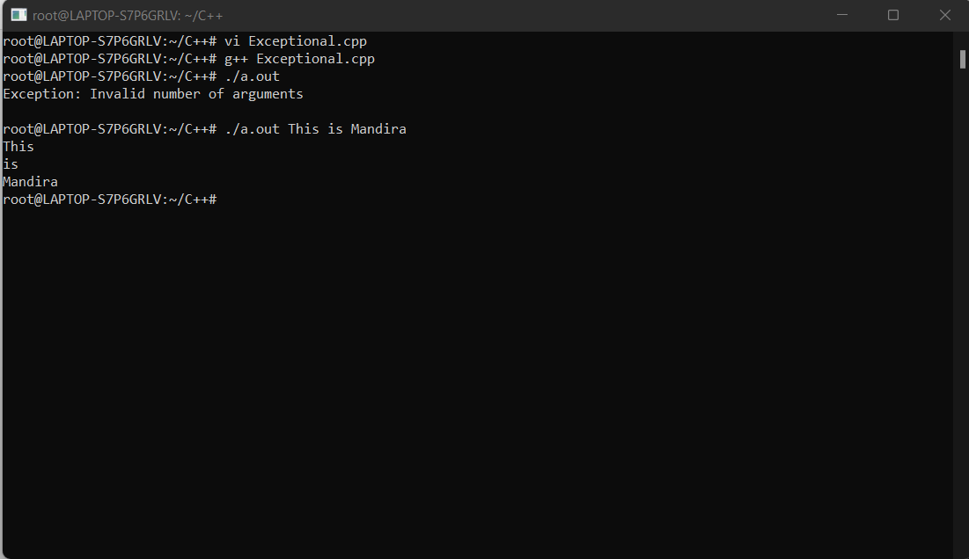an overflow or underflow error